Your Name:

Driver Education

Study Guide

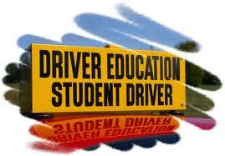

Getting and Keeping your Drivers Licence

Step 1 Your Learner Permit

How long till you can take your driving test?______________

Can you drive after dark?__________________

Who must supervise you when driving?

Step 2 Junior Licence

Who can be passengers in your car?

Under what conditions can you drive between 9pm -5am?

Step 3 Full licence

Keeping your licence

What is the probationary period?

Describe the point system

How many points in an 18 month period will result in suspension of your licence?________

How much will you pay for a Driver Responsibility Assessment
if you accumulate 6 points in an 18 month period? _________________________

List 4 legal documents you must carry when you drive
Assessing and Managing Risk

Name the elements of the SIPDE system. Describe each

- S_______________________________________________________________

- I________________________________________________________________

- P_______________________________________________________________

- D_______________________________________________________________

- E_______________________________________________________________

The Smith System

- Aim high

- Keep your eyes moving

- Get the big picture.

- Make sure others see you

- Leave yourself an out
Getting to know your vehicle.

Primary Controls

Ignition-

Gearshift-

Steering Wheel-

Brake Pedal-

Parking or emergency Brake-

Accelerator-

Gauges

Besides your Speedometer, Odometer, and gas gauge you need to pay attention to…

Engine Temperature-
Oil Pressure-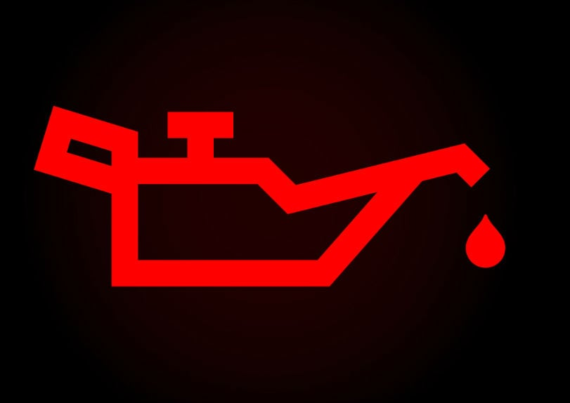
Tire Pressure light-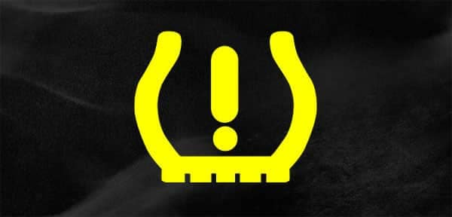
Brake light-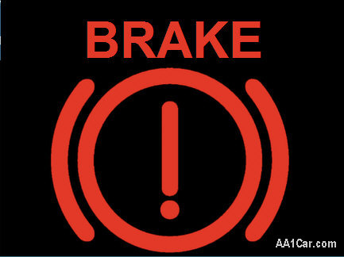
Check Engine light-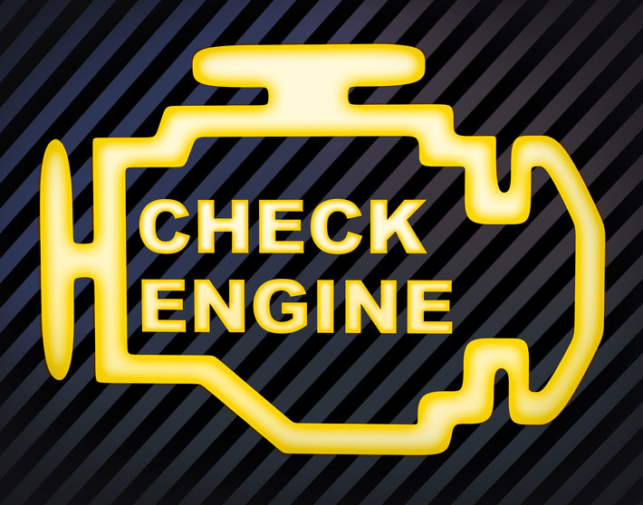
Battery Charge light-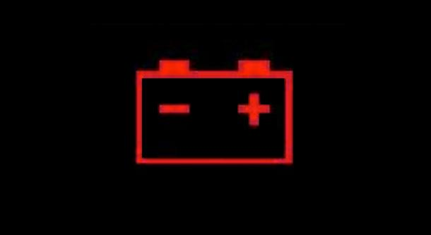

Pre driving checks-

Backing a vehicle-This is one of the most dangerous things you do when driving!

Signs, Signal, and Markings
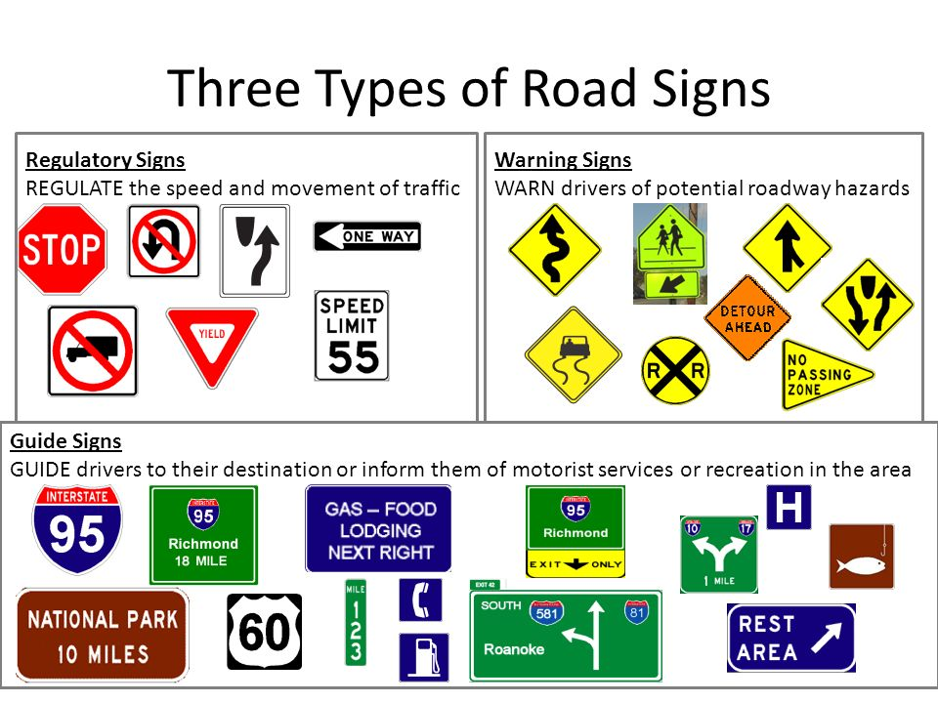
Regulatory-

Warning Signs-
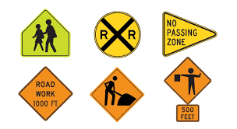

Guide Signs-

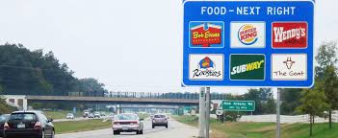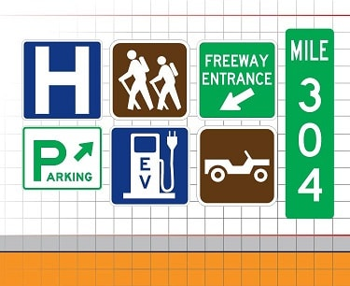
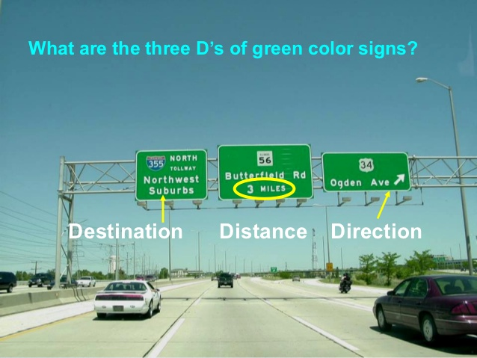

Signals 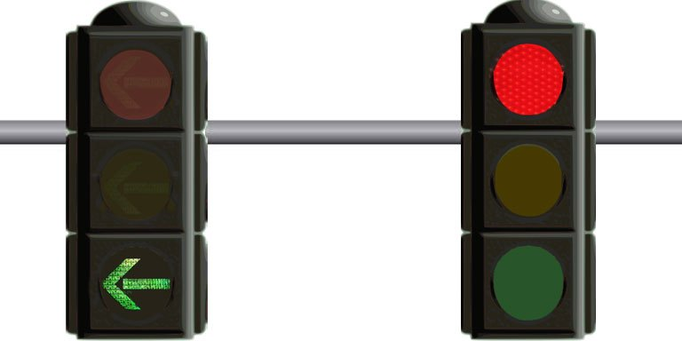

Red Light-

Yellow Light-

Green Light-.

Green Arrow-

Flashing yellow-

Flashing red-

What do these signals mean?

Pavement Markings

Yellow lines-

White lines-

On a divided highway-

Broken yellow

Solid Yellow-

Solid White-
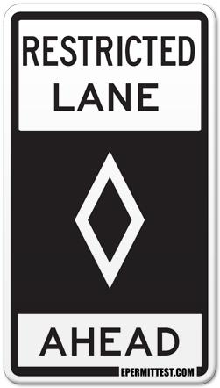
Traffic Officer-
Rules of the Road- Right of way

Right of way laws and the uniform vehicle code-

Pedestrians- Emergency vehicles with lights on-

All intersections-

First to arrive, first to go

Tie goes to the right 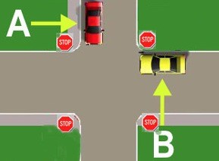

Straight before turns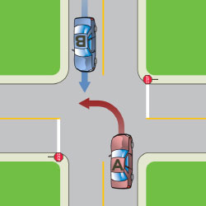

Right then left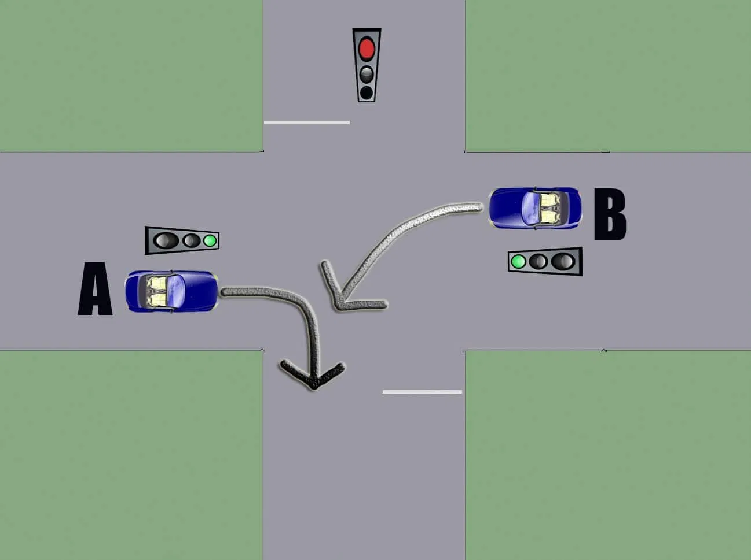

T intersections-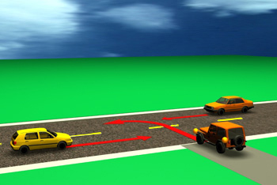

Roundabouts- 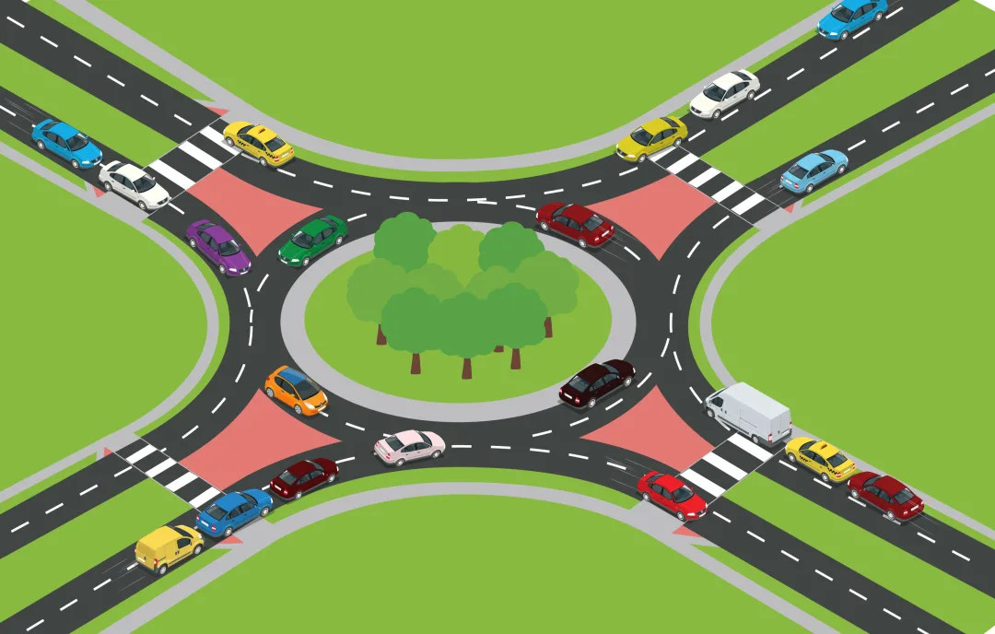

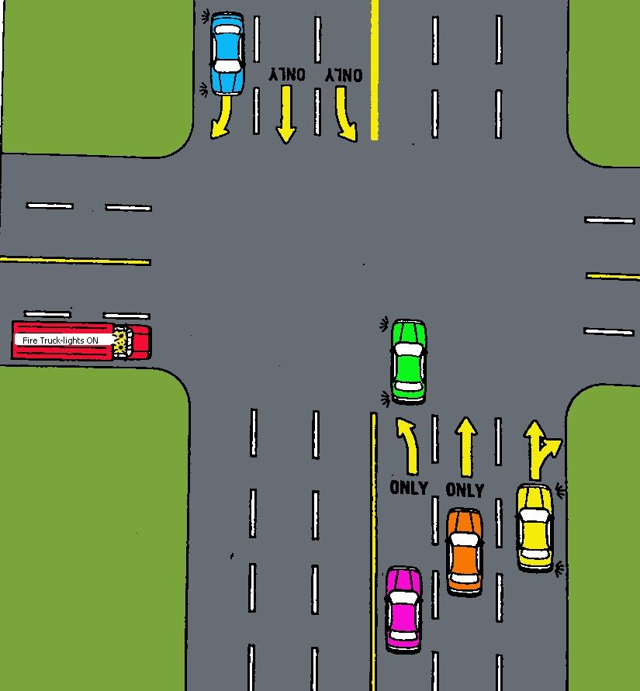

Who moves…

First

Second

Can the yellow car turn left?
Basic Driving Skills

Procedures for Pulling to the curb, leaving the Curb, and lane changes.

1.
2.
3.
4.
5.

If you need to reverse directions what are your options?
FYI we call this a turnabout

True or False

1 The safest turnabout is the three-point turn T F

2 You should have 500 feet of visibility before doing a turnabout T F

3 Driving around the block is often the easiest and safest turnabout. T F

4. A good location for a three-point turn would be immediately after T F
turning up the wrong street.

5. A two-point turn heading into a driveway on the right is considered one
of your safer turnabouts. T F

Parking-

How close to a fire hydrant can you park?

Why isn't it a good idea to park next to a car that is poorly parked?

What is standing?

When parking on a hill what two things should you do?

1.

2.

Passing-

Is it safe?
Is it Legal?
What will I gain?

Passing on the left-

Passing on the right-

T F It is illegal to accelerate when you are being passed.

T F You should signal your intent to return to the right lane when passing when you
can see both headlights in your sideview mirror

T F You may legally exceed the speed limit when passing

Driving hills

Tailgates-

Is it a good idea to brake check a tailgater? Why or whynot?

How can you prevent someone from tailgating you?

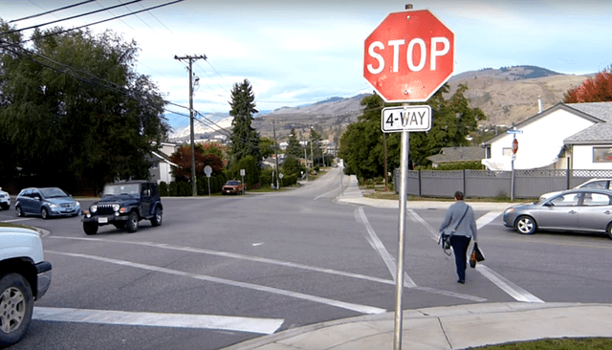
Come to a complete stop

Physics of Driving 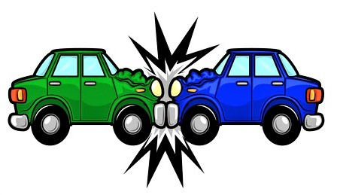

Match These Key Terms

Gravity

Center of Gravity 1. The adhesion, friction or grip between
the tires and the road surface

Inertia
2.The amount of energy needed to
propel a vehicle
Traction

3.The point around which an object’s
Kinetic Energy weight is evenly distributed

Vehicle Suspension Balance 4.The distribution of the weight of the
vehicle on the chassis

5.An object in motion continues to move
straight ahead until acted upon by some
outside force

6. The force that pulls all things to Earth

Total stopping distance consists of what 3 things?

As speed doubles stopping distance increases Times.

List factors that affect braking distance

An active protective device is one that requires you to do something in order for it to work. Give an example. Brakes, seatbelts

3 collisions in a crash 1. Car hits something, 2 Occupants hit some part of the car. 3 Internal organs crash into skeletal structure.

Vehicle maintenance

True or False

- You should check engine oil with the engine running T F

______________________________________________________________

- The radiator cap should only be opened when the radiator is cool. T F

_______________________________________________________________

- You should check your oil levels once a year T F

_______________________________________________________________

- The treads on a tire are there to help you stop on dry pavement T F

________________________________________________________________

- You should change your engine oil every 2000 miles T F

_______________________________________________________________

- Synthetic oils last longer between oil changes than conventional. T F

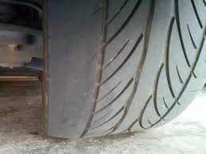Why might uneven wear occur?
Rotating your tires every 6000 mi. Means…
Which is the best fuel for your car? 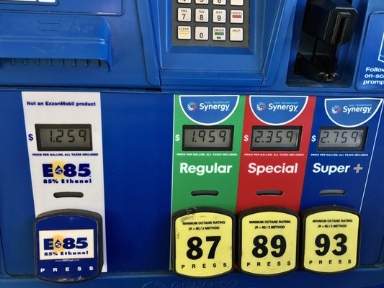

Emergency Procedures

True or False Correct false statements

- The Good Samaritan Law states that you must stop and give aid to the injured in a road emergency.
T F

______________________________________________________________________

______________________________________________________________________

- When you help somebody who has been injured in a collision. It is important to move the person off the roadway as quickly as possible.
T F
______________________________________________________________________

______________________________________________________________________

- To stop bleeding, apply direct pressure to the wound. T F

- The three procedures listed below are possible ways of slowing your car in case of total brake failure. Match each procedure with its results.

______ 1. Shift to a lower gear. A. Slows the rear wheels.

______ 2. Pump the brake pedal rapidly. B. Slows the engine and forward
movement of the vehicle.

______ 3. Use the parking brake, keeping your C. May build up pressure in the
hand on the release button or handle. Brake-fluid lines.

Circle all the items you should carry in your car to deal with emergencies.

Full can of spare gas Can of Fix a flat Spare tire

Jack Lug wrench Owners manual Tire pressure gauge

Blanket Jumper Cables Flairs Extra medicine

A lighter flashlight small shovel warning triangle

In case of an accident-

Should you move your vehicle to the side of the road?

Instructions: Place the following steps in order if involved in a collision.

_______ Get the names of witnesses

_______ Call for help/notify authorities

_______ Warn other motorists

________ Stay calm

_________ Stop

________ Exchange information

True/False

_____ It is a criminal violation to leave the scene of a personal injury crash.

_____ It is a criminal violation to leave the scene of a fatality crash.

_____ You do not have to stop if collision only involves minor damage to property.

_____ If someone is injured or killed the police must be notified.

Steps for using jumper cables

- _______________________________________________

- _______________________________________________

- _______________________________________________

- _______________________________________________

- _______________________________________________

- ______________________________________________

Put an X next to the correct steps to take if your car is running hot or overheating.

_____ Drive slower

_____ Turn your heat on

_____ Turn your air conditioner on

_____ Open your hot radiator cap to add coolant

_____ add coolant to your overflow tank

Tire changing if you get a flat. Correct false statements

- You can locate the jacking points of your car by looking under it T F

_____________________________________________________________________

- Changing your tire on the side of the road is dangerous T F

______________________________________________________________________

- Your spare tire requires that you check its air pressure periodically. T F

______________________________________________________________________

Light and Weather Conditions

Provide brief answers to the following

1. When driving at night with no other vehicles present, use…

2. Overdriving headlights means…
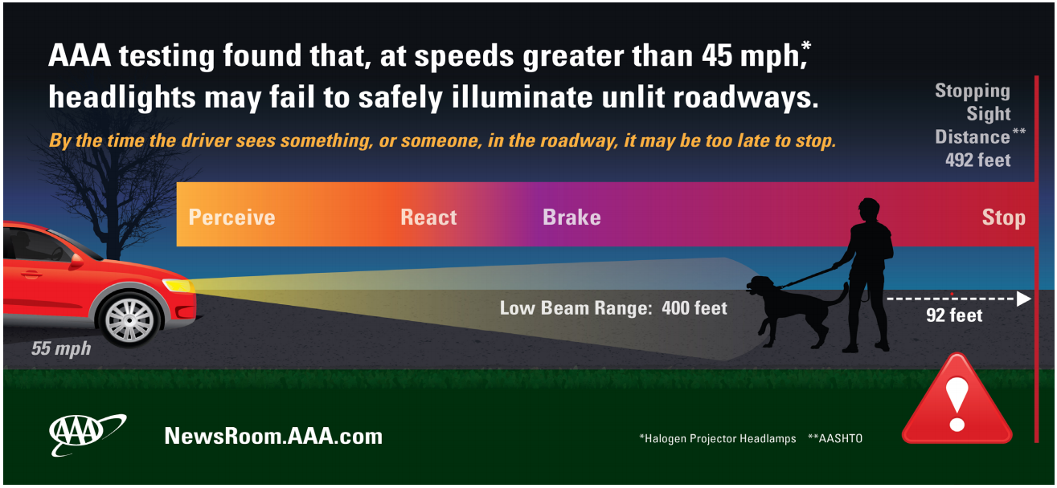

3. When your headlights shine into fog…

4. When driving in snow you should…

5. Hydroplaning occurs when…

6. In all high wind situations…

7. What is “black ice”?

8. Why can a bridge surface freeze before adjoining road surfaces do?

9. When driving in the winter you should carry …

10. If you are driving into sun glare from bright sunlight, you can reduce glare and eyestrain by…

True or False

1. Hydroplaning occurs when your vehicle rides up onto a thin film of ice. True or False

2. The moth syndrome refers to a driver's eyes being attracted to the light of oncoming vehicles or on buildings. True or False

3. When it is snowing, drive in the tire tracks left by other vehicles. True or False

4. Roads are most slippery the first 15 minutes of a rainstorm. True or False

5. Drive with high beam headlights when you encounter fog. True orFalse

6. Fishtailing occurs when the rear of the vehicle swerves back and forth. True orFalse

7. In adverse weather conditions, reduced traction is far more critical for motorcyclists
than for drivers of other types of vehicles. True or False

8. Driving with the cruise control on is not recommended in adverse weather conditions.
True or False

Multiple Choice

9. Using high beams at night….
a. is illegal
b. should be used if there is fog
c. should not be used when there is oncoming traffic
d. all of the above

10. Using headlights during the day....

a. can decrease your visibility for others
b. Can increase the ability of others to see you by 2,000 feet
c. is a waste of energy
d. is required by New York State when it is raining
e. Both b & d

Short Answer 11. List three ways you can be seen by other drivers when you find yourself in an emergency

Driving Environments

Managing Visibility, Time, and Space

How can you be more visible when driving?

True or False- Correct false answers.

- Road grime can reduce headlight illumination by as much as 60% T F

____________________________________________________________________

- Using daytime running lights or low beam headlights during the day makes your vehicle more visible about 220 feet sooner than driving without either. T F

_____________________________________________________________________

- It is a good idea to clean the inside and outside of your windshield. T F

______________________________________________________________________

- You should keep a minimum of 3 seconds between you and the car in front of you. T F

______________________________________________________________________

- 30 seconds ahead equals about ½ mile at 55 mph T F

______________________________________________________________________

- You should decrease your following distance in bad weather. T F

______________________________________________________________________
- “Leave yourself an out,” from the Smith System involves creating open space in front, to both sides, and to the rear of your vehicle. T F
Urban Environments

What special factors affect city driving?

How can you manage …

Visibility-

Time-

Space-

Rural Environments

What special factors affect driving in the country?

How can you manage …

Visibility-

Time-

Space-

Multi-Lane Highway driving

What special factors affect driving on Highways?

How can you manage …

Visibility-

Time-

Space-

Matching- (Special Lanes)

Used to bring your car up to
Highway speeds when
Entering a highway.

Used to both enter and exit a highway

You should not slow down before
Entering the…

Used to find a gap in traffic
When merging onto a highway

Requires at least one passenger
To travel in this lane
Weave Lane

H.O.V lane

Acceleration Lane

Deceleration Lane

Sharing the Road

True or False

1 It is more difficult to tell how fast a motorcycle is going than a larger vehicle.

2 Motorcycles can easily hide in the blind spot of cars.

3 Bicyclists do not have to obey the same traffic laws as cars.

4 You should pass large trucks on the highway by using the right lane.

5 If you see an emergency vehicle with its lights flashing you should
pull over to the left to let it pass.

6 A truck may have a blind spot as large as 20ft immediately in front of it.

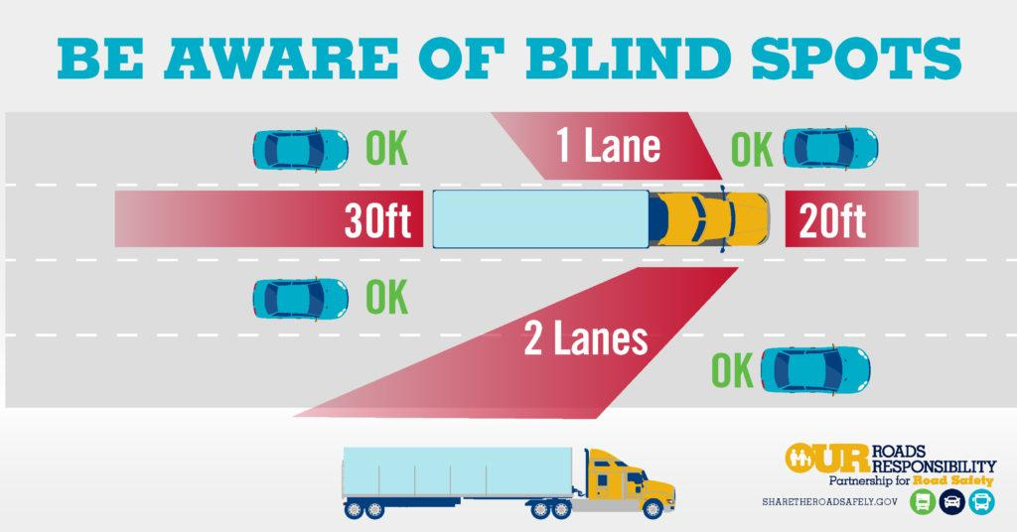

Emergency Procedures.

Brake Failure

The three procedures listed below are possible ways of slowing your car in case of total brake failure. Match each procedure with its result.

- Shift to a lower gear a. Slows the rear wheels

- Pump the brake pedal rapidly b. Slows the engine and forward
Movement of the vehicle

- Use the parking brake, keeping c. may build up pressure in the
Your hand on the release button or brake-fluid lines.
handle.

Suppose you tried the above methods without success. Study the picture. Explain what you might do at each numbered spot if you were driving vehicle X and your brakes failed.

1.

2.

3.

4.
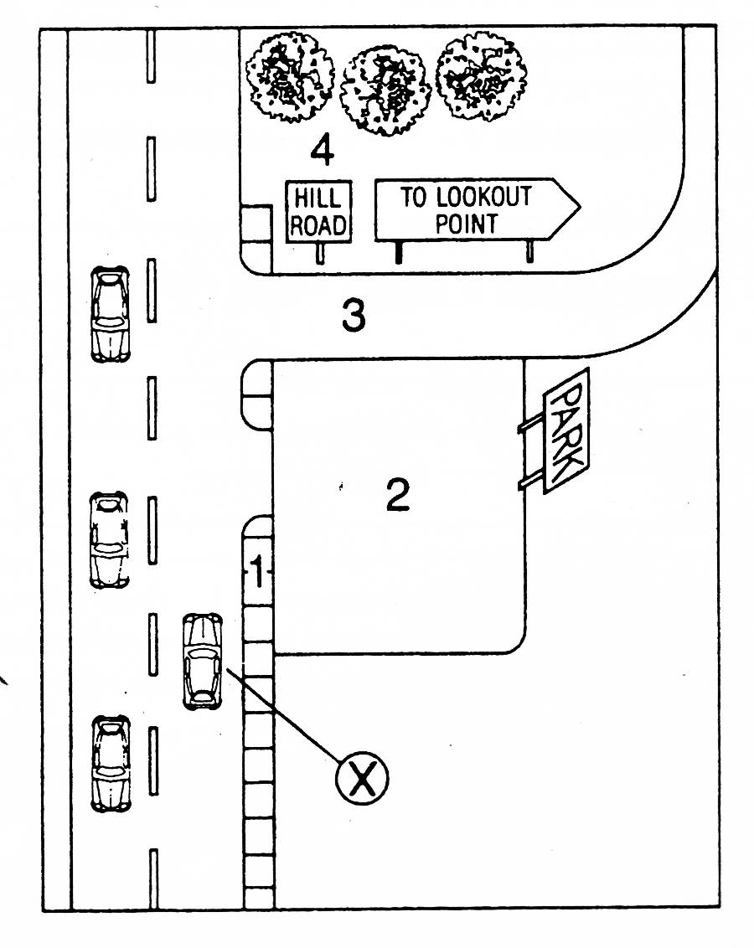
Skids

Describe the following types of skids and how to recover from them.

Braking Skid-

Power Skid-

Cornering Skid-

Blowout skid-

Collision avoidance

What are the 3 actions a driver can take to avoid an imminent collision.

1

2

3

True or False Correct false answers.

1 To avoid a head on collision always steer to the right.

_________________________________________________________________

2 If you drop a wheel off the road brake and steer quickly back onto the road.

__________________________________________________________________

3 Over correcting steering means applying too much turn in the wheel to correct a skid.

____________________________________________________________________
Car Crashes.
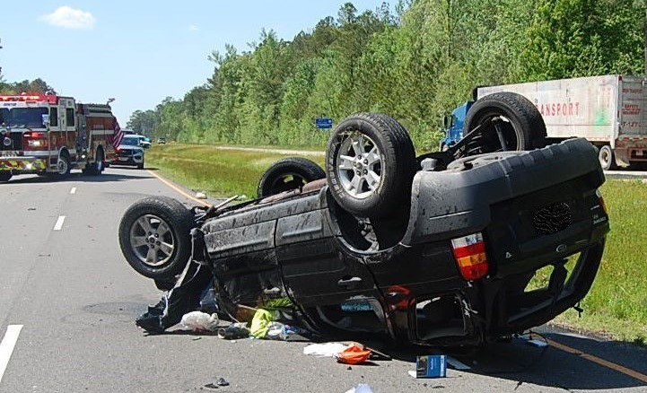

Steps in order to take after a crash has occurred...

- Check on injuries to yourself, passengers, then others involved in the crash.
Moving victims-

- If possible move vehicles off the road. Set out warning devices.
Warning devices-

- Call 911

- Exchange information and document the accident

- Report the accident to the dmv and your insurance company.

A crash victim is bleeding heavily. How can you help them until first responders arrive?

The good Samaritan Law states...

If your accelerator is stuck and you are speeding out of control what should you do?

According to the Move over law if you can't move over a lane for an emergency vehicle you should...

Jump Starting a Dead Battery

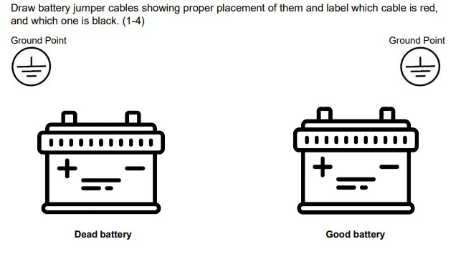

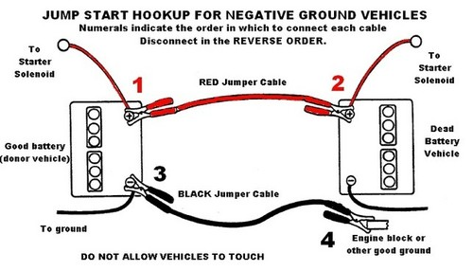

Knowing Yourself

Distraction-
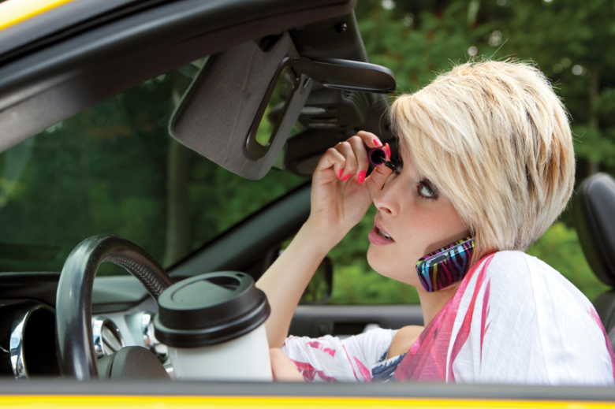
How is the SIPDE Process Affected by Distractions?

How would you handle the following distractions?

Music-

Cell Phones-

Gps/ Navigation-

Loud/ Rowdy Passengers.

Animals in the vehicle

Eating
Alcohol Use and Driving

How does alcohol affect driving?

Your B.A.C. is determined by (circle all that are true)

Age Weight Amount you drink Time

Answer the following questions based on this graph.

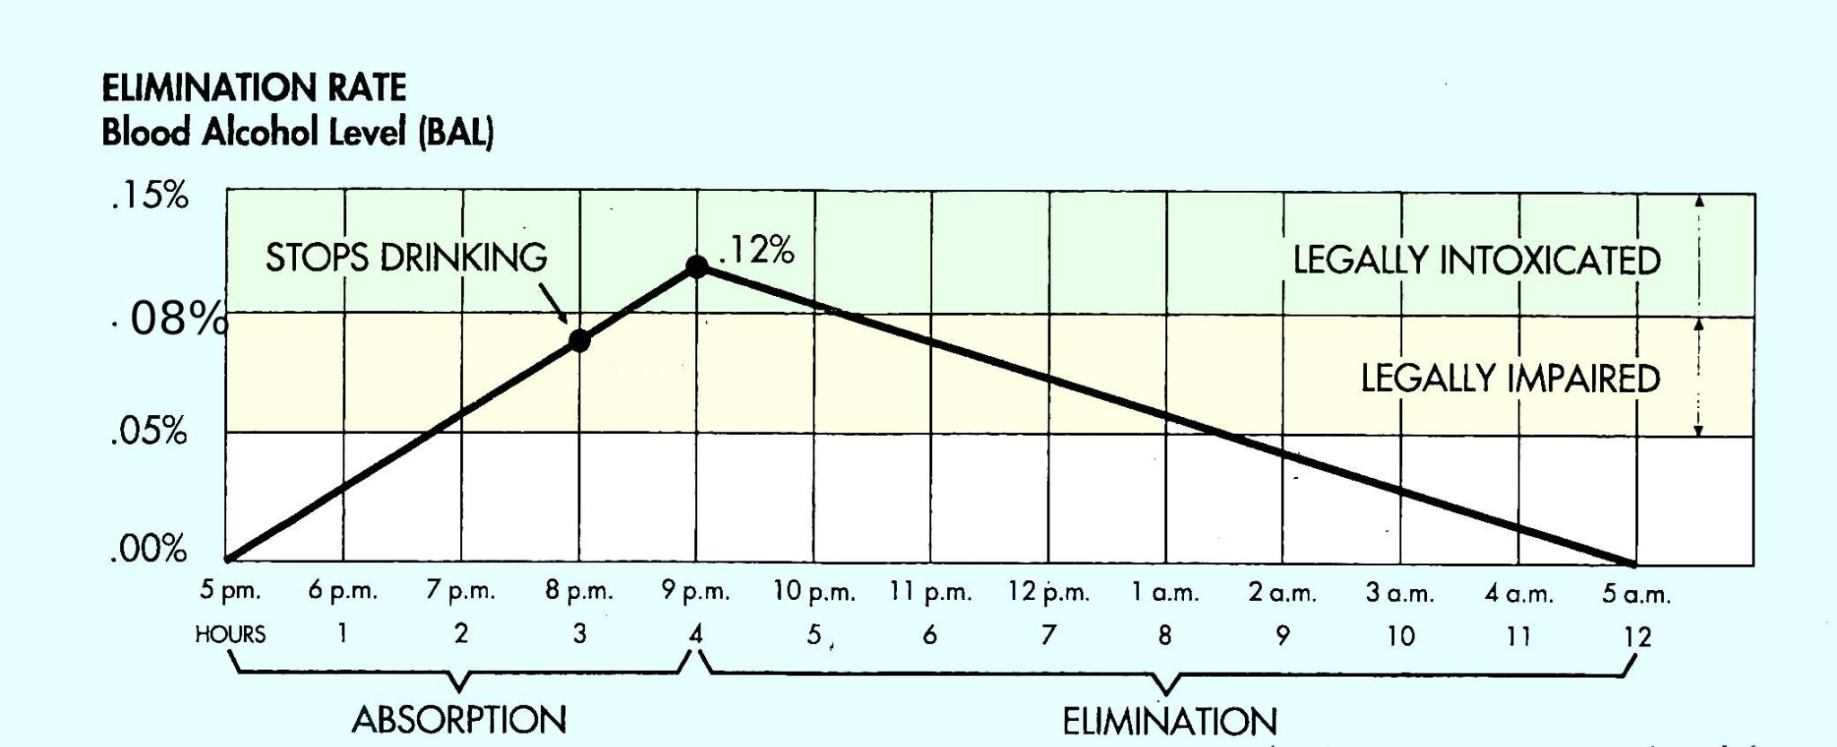

- For how long does alcohol remain in a person’s blood?____________________

- Between what hours should the person in the graph not drive?______________

- For approximately how long is the person in the graph legally impared?_______

- Between what hours is this person legally intoxicated?_____________________

- For how long after the person stops drinking are they legally impared?________

- What is the alcohol level at the time elimination starts?____________________

- Is the person impared longer while absorbing or eliminating the alcohol?
Which of the following pictures contains the most total alcohol?

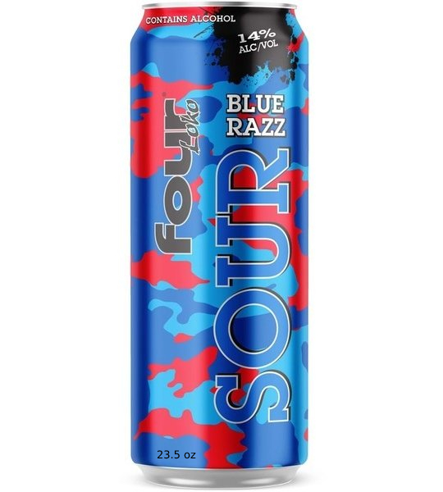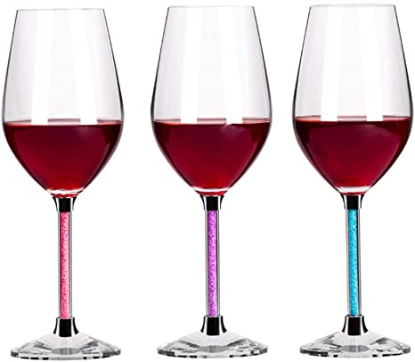
You are going to a party and expect to be drinking alcohol. What is your plan to keep you safe?

Leandra's Law is named after Leandra Rosado, an eleven year old girl who was killed in a car crash after the driver, who had allegedly been drinking for several hours prior to the crash, lost control of her vehicle on the Henry Hudson Parkway. Leandra's Law, which became effective December 18, 2009, sets some of the toughest DWI provisions in the country. Under Leandra's Law:
- First time offenders driving while intoxicated or impaired by drugs with a child less than 16 years old in the vehicle may be charged with a class E felony, punishable by up to four years in State prison.
Emotions and Driving
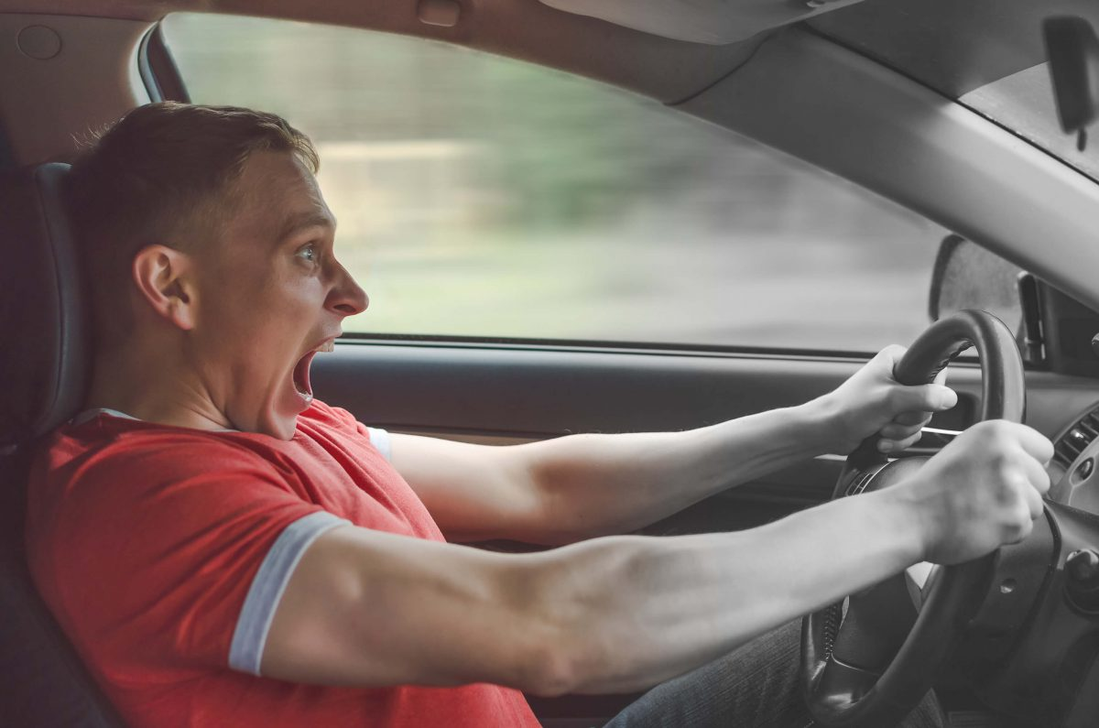
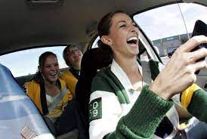

List some emotions that may have a negative effect on driving

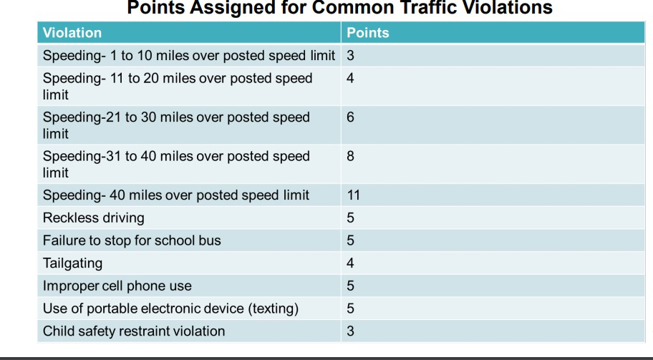
What are possible outcomes of highly emotional driving?

